Work 6. H-infinity optimal control design

Problem statement
Disturbed linear plant of variant 5:
$\overset{˙}{x}=Ax+Bu+B_{f}f,x(0)=[1, 0]^{T}$
$A=\left[\begin{matrix}6 & 2 \\ −3 & 0\end{matrix}\right], B=\left[\begin{matrix}0 \\ 3\end{matrix}\right], B_{f}=\left[\begin{matrix}4 \\ 1\end{matrix}\right], Q=diag(2,7)$
$f=10sin6t+5cos2t+4cos3t+3cos8t$

Synthesis and minimal gamma
The H-infinity Riccati equation is solved while decreasing gamma until a stabilizing positive semi-definite P no longer exists; that boundary gives gamma_min. A coarse grid locates the boundary and a bisection then refines it to the tolerance below. Exactly at gamma_min the solution P is unbounded, so the controller u=Kx with K=-B'P is synthesized at a slightly suboptimal gamma = 1.01 gamma_min, which keeps P bounded and the closed loop realizable; u and the states are plotted for this gamma.
$A^{T}P+PA+Q−PBB^{T}P+γ^{−2}PB_{f}B_{f}^{T}P=0$
$K=−B^{T}P$
gamma_min = 9.4549 (bisection tolerance 0.0001)
design gamma = 9.5494
K = ['-1407.2370', '-208.3269']
closed-loop eig real parts = ['-7.6879', '-611.2929']
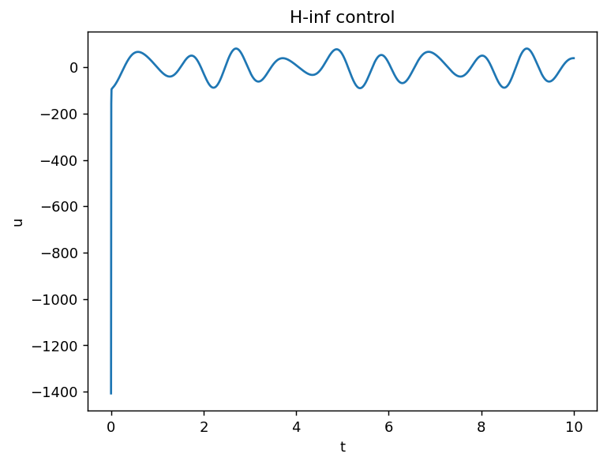
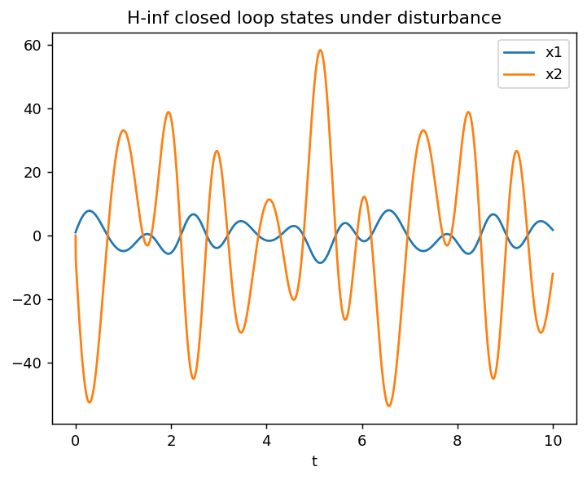

H-infinity norms of disturbance transfer functions
Norms are computed by a frequency sweep of the closed-loop transfer function from the disturbance to each output.
||C1 (sI-Acl)^-1 Bf||_inf = 0.5324
||C2 (sI-Acl)^-1 Bf||_inf = 3.5971
||(sI-Acl)^-1 Bf||_inf = 3.6363
